INSY 4305/5352 Assignment #1

(1) Write a program that displays 10 randomly generated traingles in different random colors. Each triangle should be filled with a different color. Use class **GeneralPath** and method **fill** of class **Graphics2D** to draw the triangles. Make sure to use a different **GeneralPath**object for each triangle. You should name the file HW1a.java   
[Sample Output](https://elearn.uta.edu/bbcswebdav/pid-4247259-dt-content-rid-15415846_1/users/rsikora/INSY%204305%20my_files/HW/ex11_11.html)

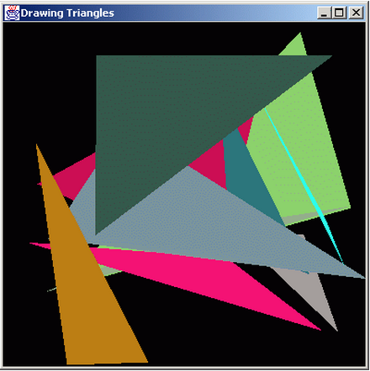

(2) Write a program that allows the user to select a shape (Circle, Square, Oval, or Rectangle) from a **JComboBox**, then draws that shape 20 times with random locations and dimensions**.**The first item in the **JComboBox** should be the default shape that is displayed the first time **paint** is called. (*Note:* Remember to use **repaint** to display the new set of shapes each time.) You should name this file HW1b.java   
[Sample Output](https://elearn.uta.edu/bbcswebdav/pid-4247259-dt-content-rid-15415846_1/users/rsikora/INSY%204305%20my_files/HW/ex12_24.html)

